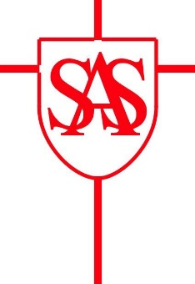

St. Alban & St. Stephen Catholic Primary School & Nursery
Nursery 2021-22: Session Information
Our Nursery offers each child 15 or 30 hours provision dependent on their needs.
Option 1: 5 morning sessions 08.45-11.45 or 5 afternoon sessions 12.15–15.15
Option 2: 30 Hours * Monday – Friday 08.45-15.15
* involves a cost of £4 per day to cover the cost for the last session of the day as this is above the 30 hour free entitlement
If any option is oversubscribed, spaces will be allocated in accordance with our Admissions Policy.
Additional sessions may be available once numbers have been confirmed at a cost of £20 per session (or payable with 30 hour free childcare funding – see information below). Additional Lunch Club sessions will be charged at £4.

30 Hours’ Free Childcare Information
A 30 hours’ free childcare checklist has been developed for parents/carers which covers some frequently asked questions, deadlines and when you can access the entitlement. The checklist can be found via the following link: https://www.hertfordshire.gov.uk/media-library/documents/schools-and-education/childcare-and-advice-for-parents/30-hours-free-childcare-checklist-for-parents.pdf
We will offer 30 hour places until all spaces are filled. You can check the following website to confirm your eligibility for 30 hour free childcare provision – https://www.gov.uk/childcare-calculator. You will need to reconfirm this to us through an 11 digit code every 3 months.
Please complete the Options Form overleaf, indicating reasons for your preferences in the box below.

Options Form

Child’s Name ___________________________ Date of Birth ______________

Please indicate from the following options.

AM: 5 mornings at Nursery 8.45-11.45

PM: 5 afternoons at Nursery 12.15-15.15

30 Hours: Full-time

Reasons for Preference

Signature: __________________________ Date: _________________

Please return this form by Friday 26 February 2021. Thank You.

