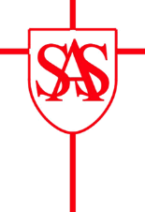
SS Alban and Stephen Catholic Primary School & Nursery
Reception Parent Home Learning – Spring 2 - 2020

Our topic this half-term will be ‘Off On An Adventure’

Date and Weekly Topics | Phonics | Additional Home Learning
Week 4 – 15/03/21
Supertato

Week 5 – 22/03/21
Supertato

Key Dates:  19/03/21 – World Book Day 2 |  | Key Information:

