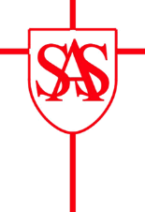
SS Alban and Stephen Catholic Primary School & Nursery
Reception Parent Home Learning – Summer 1 - 2021

Our topic this half-term will be ‘Down in the Garden’.

Date and Weekly Topics | Home Learning Ideas
Week 1 – 12/04/21  The Very Hungry Caterpillar | - Retell the story of ‘The Very Hungry Caterpillar’ – can you make your own caterpillar/butterfly artwork?  - On your journey to and from school, can you spot any minibeasts?  - Make a book for the Creation Story, drawing and writing what God made on each day.
Week 2 – 19/04/21  The Very Hungry Caterpillar | - Research the lifecycle of a caterpillar – can you make a fact book.  - Can you share any recent good news on Tapestry to show the class?
Week 3 – 26/04/21  What The Ladybird Heard | - Can you make your own minibeast habitat?
Key Dates:  - 3rd May – Bank Holiday (School Closed)  - 6th May – Parent Consultations |  | Key Information:  - Reading Books – please make sure reading books are in the children’s book bags all week. These are collected on Wednesday and sent out on Friday.  - PE – Please make sure the children have their PE kit in school by Friday each week.

