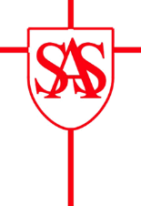
St Alban & St Stephen Catholic Primary School & Nursery

Reception Parent Home Learning – Summer 2 - 2021

Our topic this half-term will be ‘At The Seaside’.

Date and Topic | Home Learning Ideas
Week 2 – 14.6.21  ‘The Troll’ by Julia Donaldson | - Optional Phonics Sounds – ‘oa’ and ‘oo’.  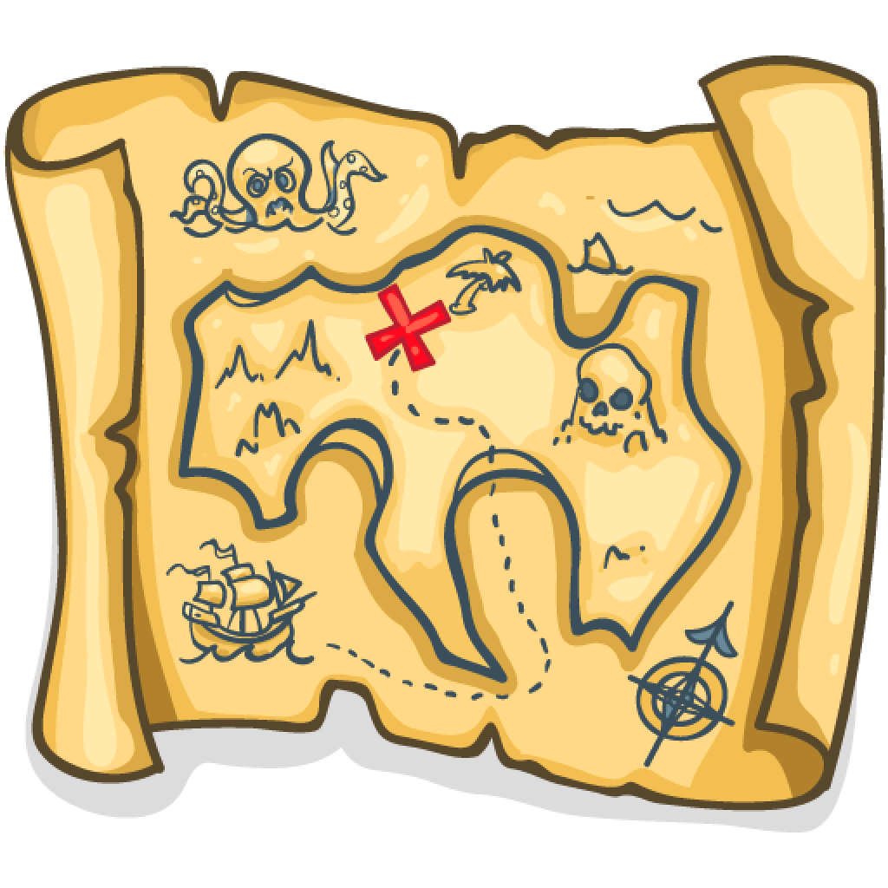  - Hide some ‘treasure’ somewhere in your house or garden. Draw a treasure map and put an X to mark the spot. Can you family find the treasure?  - Create 2 treasure chests. Using real coins, how many different quantities can you share between the 2 groups. What do you notice about odd amounts?
Week 3 – 21.6.21  ‘The Troll’ by Julia Donaldson | - Optional Phonics Sounds – ‘ar’, ‘or’ and ‘ur’.  - Write a list of things you need to take to the beach.  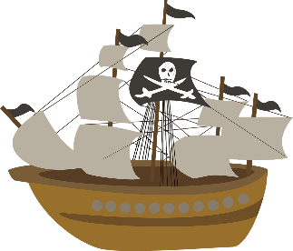  - Can you create a pirate ship using a range  of materials? Does it float?  - What makes our world so wonderful? Go on a nature walk and take photos of the wonderful world around us.
Week 4 – 28.6.21  Sea Creatures | - Optional Phonics Sounds – ‘ow’, ‘oi’ and ‘ear’.  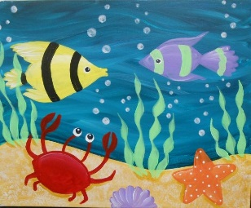  - Research your own sea creature using a range of media i.e. books, computers. Make a fact file, writing as many facts and sentences as you can!  - Create your own sea scape, using paints, chalk or crayons.  - Find 4 items around your house. Predict and then test if they will float or sink. Write down why certain materials float and sink.
Key Dates:  Green Day – 16.06.21  Class Photos – 23.6.21  Sports Day – 29.6.21 |  | Key Information:  - Please make sure you have applied sun cream to your child before school.  - All items of clothing must be labelled, including PE kits and red sun caps.

