Ss Alban and Stephen Catholic Primary School
Year 2 Home Learning – Autumn Term 2022
Weekly activities
- Children should read for a minimum of 10 minutes each night and parents should sign the reading record.
- Weekly maths Home Learning is set on Wednesday and is due in on Monday. This will be set on ‘My Maths’ which you access online or from time to time it may be a maths sheet.
- Each Wednesday, spelling practise will be added to Google Classroom for you to practise with your child.
- Don’t forget to keep practising on ‘Numbots’ as well.
Grid Home Learning
Children from Year 1 and 2 should complete at least 2 pieces from the grid Home Learning in the half term, plus 1 RE piece. The grid will be uploaded to Google Classroom and children should submit their work via Google Classroom as and when they complete a task. If a child wishes to do more pieces they are more than welcome to.
The tasks are all open ended, so you can present them in any way you choose, and you can extend them as much as you wish. Work which cannot be uploaded can be brought into school to share with the class (e.g. Art activities) but will be marked on Google Classroom.
We expect you to choose a variety of activities.
We look forward to seeing all your wonderful Home Learning this term. You could even gain up to 3 house points for impressive work!
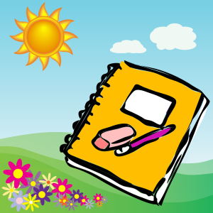
Mrs Cooper, Mrs Duffey and Miss Campion.

Grid Home Learning – Autumn 1st Half Term
Our topic: London!
Year 2 Home Learning – Autumn 1 2022
English | Maths | RE
Write a diary entry about your weekend or a two days of your choice in your week. | Number  Create a game that helps you to practise your number bonds to 10 and number bonds to 20. | Write a prayer for one of these reasons:  - To thank God for your talents or blessings in your life  - To ask God for help and support throughout this school year  - To ask God to watch over you and your family  Make sure it is presented beautifully!
Write a description of a character from your favourite book. Think about what they look like and what their personality is like. Would you like to be friends with them and why? | Money  Help your parents make a shopping list. Take the list when you go shopping with your parents and write down how much each item costs, on the list. | Choose a story from the Old Testament of the Bible. Talk about the story. Create a piece of artwork that shows the characters and retells the story.
Write a set of instructions for something like making a cup of tea, or playing a game. Use diagrams and label them. | Survey  Watch the cars going past for a few minutes and record the number of different colours that go past.  - Red  - White  - Black  - Silver  - Etc… | Design a piece of art about Mary. Make sure you show how important she is to Jesus and to us.
Cross Curricular
Help your parents to bake something and write a list of the ingredients and instructions on how to make it. | Create a piece of art work about something in nature or make a model of a famous London Landmark. | Create a fact file about your favourite animal, include facts on  - Habitat (where it lives)  - Diet (what it eats)  - What it looks like  - What part of the world it comes from.

