St Alban and St Stephen Catholic Primary School
Learning and Growing with God by our Side
Year 4 Homework –Autumn Term 2023
Weekly activities
- Homework is set on Wednesday and is due in on Monday.
- Each Wednesday, spelling lists will be issued which should be practised every night. There will be a test on the following Tuesday.
- Children should read for a minimum of 20 minutes each night and when possible discuss this with parents/carers who should sign the reading record. The infographic below details the impact of regular reading.
- They will also receive Maths homework set on ‘My Maths’ which can be accessed online.
- Children are expected to use ‘Times Table Rock Stars’ regularly to ensure that they can recall these facts instantly. If your child is not confident with number bonds to 100, please also practise on Numbots.
Grid homework
Year 3 and 4 children should complete children should complete a minimum of three pieces of homework each half term (at least six in total each term) including two pieces of R.E. homework during the term. These can be submitted on Google Classroom as and when they are completed.
The activities grid will be set on Google Classroom. Children should submit their homework and any photos through Google Classroom. If they decide to make a poster, this can be brought into school but marking will be shown on Google Classroom.
The tasks are all open ended, so you can present them in any way you choose, and you can extend them as much as you wish. Choose a variety of activities and you can only choose each activity once!
We expect all homework to be completed to a high standard. House points will be awarded as follows:
3 House points will be awarded for exceptional homework.
2 House points will be awarded for good homework.

RE  We are learning about Jesus’ family tree.  Draw your own family tree.  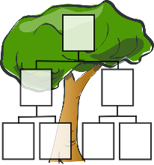 | RE  Write a Harvest prayer.  Please hand write this using your neatest joined writing and decorate it. | RE  Write your own story, song or poem about the gift of love and friendship. Remember to include the following things: gifts that are non-material and what gifts we have within us to give.
English  Record a video of you reading an extract from your favourite book aloud using expression, projection and appropriate volume. | English  Create a labelled diagram showing how a household appliance works, e.g. toaster, TV or vacuum cleaner.  This could be real or fictional, as in ‘Until I Met Dudley’. | English  Create a poster explaining what the two types of conjunction are and writing examples of how to use them.  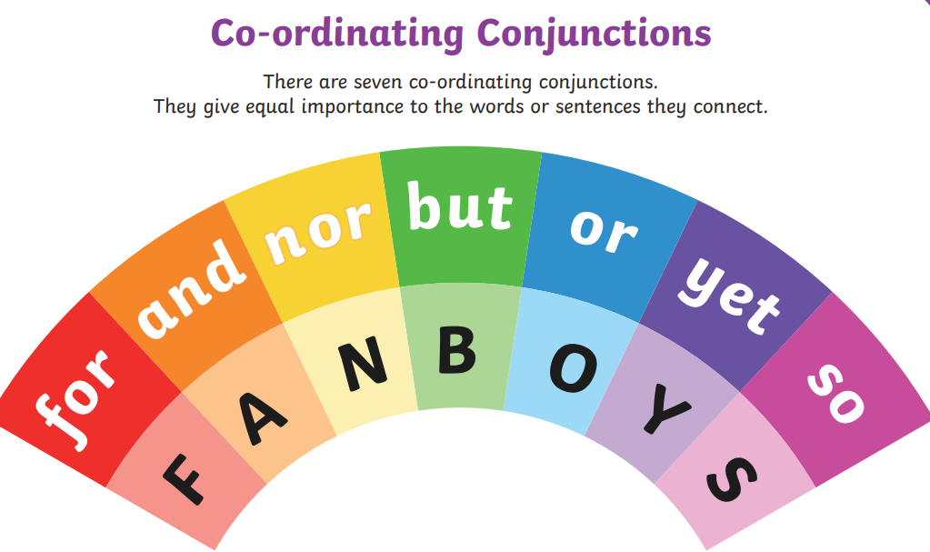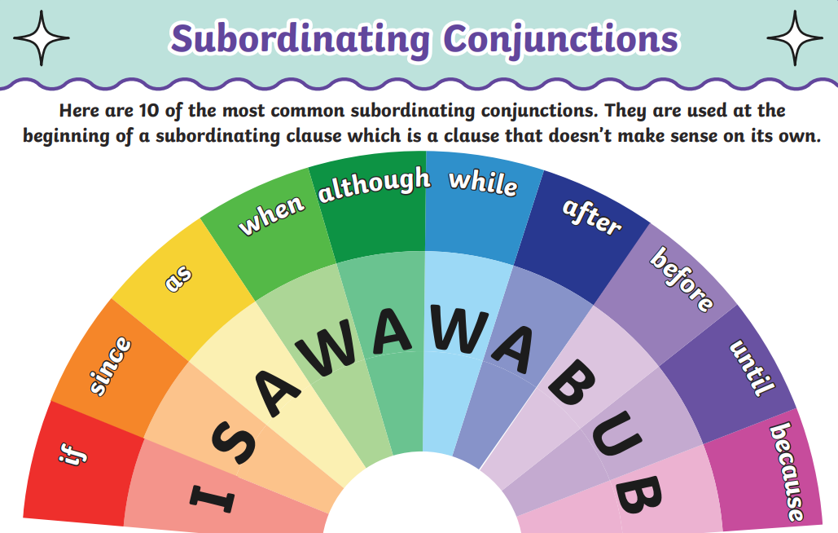
Maths  Create a poster showing vocabulary relating to the four operations: addition, subtraction, multiplication and division.  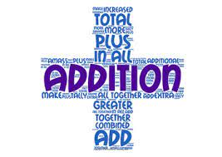  For example: | Maths - Times Tables  Complete a log of what times tables you have practised each week. Record what times tables you completed, how (e.g. TTRS, writing them out, singing) and how much time you spent doing it.  Remember little and often is the way to success!  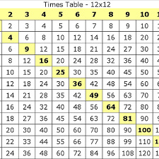 | Maths  Create a poster about how to use Roman Numerals.  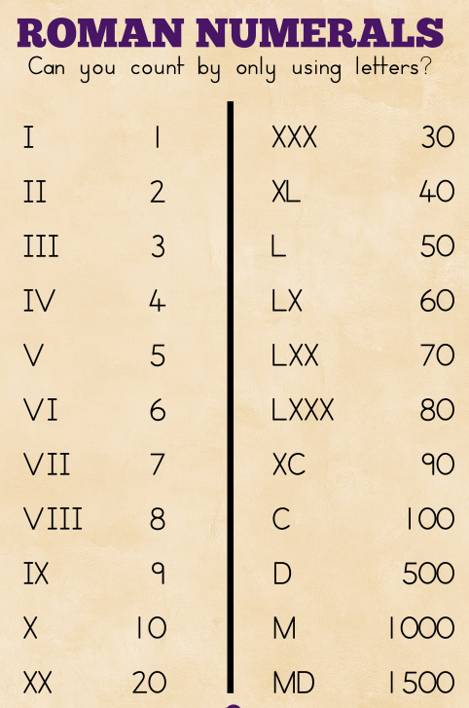  This information PowerPoint will help you.  https://www.twinkl.co.uk/resource/t2-m-1041-roman-numerals-introduction-powerpoint
Science  Make a fact file about an animal and its habitat.  This could be in any format of your choosing e.g. handwritten, poster, PowerPoint or a video. | Science  Visit a woodland, beach or other habitat. Write, draw or take photographs to explain the differences between this habitat and your local environment. | Science  Make ice cream using ice and salt. Use the recipe attached.  https://www.twinkl.co.uk/resource/au-a-42-ice-cream-in-a-bag-recipe
Design and Technology/History  Design and make a chariot fit for Boudicca. You can use any materials of your choosing. | Geography  Find out what fruits and vegetables can be grown in the U.K. When is each of them ready to harvest?  Show your results on a chart or table. | Art  Create your own mosaic picture or pattern, using a subject and materials of your choosing.
Design and Technology  Find and follow a Roman recipe. Take pictures showing you creating and eating your meal. | PSHE  Create a poster about teamwork. You could include how to be a good team member or how it makes people feel. | Art/Design & Technology  Create your own art relating to or build a model of one of the Roman features in or around St Albans. For example, the amphitheatre, the hypocaust or a Roman relic you have seen in the Verulamium Museum.
