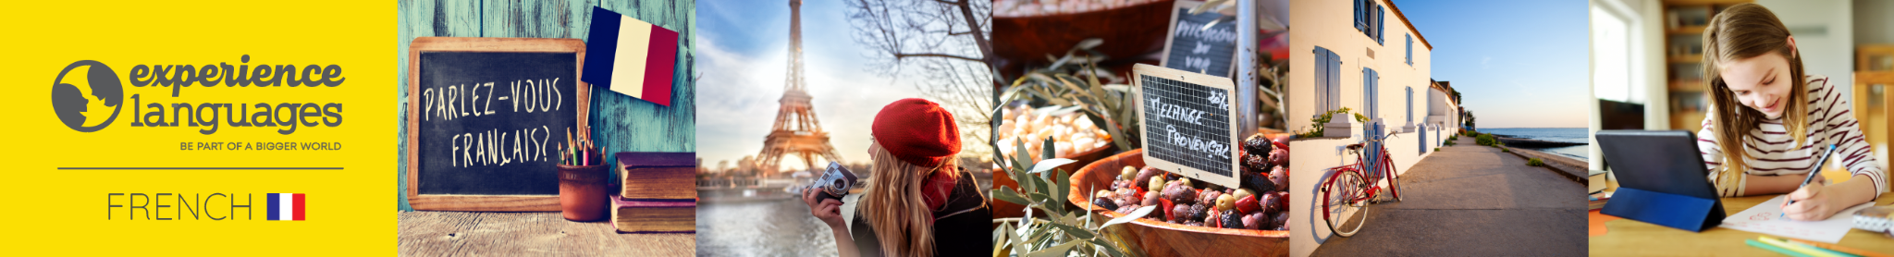

visit www.experiencelanguages.co.uk for more information on adult and online classes for adults and children.

FRENCH ONLINE (ZOOM) CLUB
FOR YEAR 5 AND YEAR 6 CHILDREN
Dear parents,

Your child will be learning French using the Skoldo scheme of work (you can visit www.skoldo.com for more information) combined with roleplays, singing, games and stories. These activities aim at enhancing children's speaking and listening skills but lessons will also aim to improve children's skills in reading and writing to ensure solid progression through Key Stage 2.

Please note that children are also sent weekly activities to help them consolidate their learning.

This online club will last for 30 minutes and will take place on Thursdays from 5.30 to 6 pm. The term dates are Thursday 14 September to Thursday 14 December.

Each session costs £5 and therefore the cost for the autumn term is £65 (£5 x 13 weeks). Your child will also be required to have the French Pupil Book 2 which you can buy directly from the Skoldo website or from Amazon.

If you would like to book a place for your child I would be grateful if you could confirm by emailing me back with your child's name. Please note that online classes will be limited to 8 children and places are allocated on a first come first served basis.

Should you require more information please do not hesitate to contact me directly on 07429 477 008 or e-mail me at christeleannis@hotmail.com.

Kind regards

Christèle

PAYMENTS
For bank transfers, please find account details below (please use your child's name as reference).

Name: Christele Annis
Bank: Halifax
Sort code: 11-18-11
Account number: 22453039

