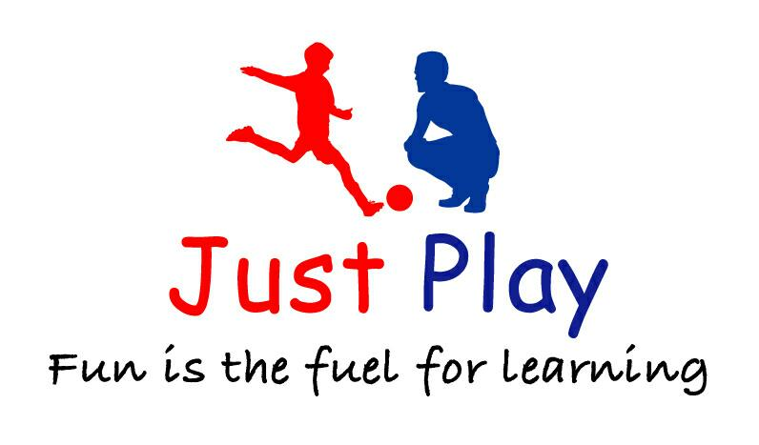**Dodgeball club**

**Years 3 - 6**

**3:30 - 4:30**

This is a private club, do not contact the school with enquiries or to book a place

The course will run for **13 weeks**

Dates of the course are Monday 11th 18th 25th September 2nd 9th 16th 30th October 6th 13th 20th 27th November 4th 11th December. **Please be aware of the prompt start time so that children have full enjoyment of the session.**

Please note for health & safety reasons the children are required to wear appropriate sporting attire. The cost of the club is **£52**. **TRY YOUR FIRST SESSION FOR FREE**, if you would like to continue the full amount must be paid. Places are limited and will be offered on a first come, first serve basis.

**Want to make a booking?**

**TO BOOK A PLACE PLEASE CONTACT CHRIS COLMAN ON 07805213978 OR EMAIL** [**JUSTPLAYUKSPORTSCOACHING@GMAIL.COM**](mailto:JUSTPLAYUKSPORTSCOACHING@GMAIL.COM)**.**

**Please note that sessions may be rescheduled if we unfortunately have to cancel a session, sessions will always be rescheduled for the next available Monday in the calendar. We will not provide a refund for any rescheduled sessions. You can find our terms and conditions on our website justplaysportscoaching.co.uk or request them from your school office.**