Learning and Growing with God by our Side

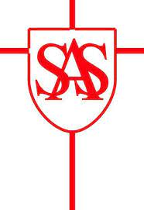

I am a Geographer - I am learning about different places, people and environments.
Geography  Progression of Skills  Year 1 |  | Pupil | Teacher
Geographical Enquiry | Geographical Enquiry  - I can ask and answer simple questions.  - I can use information books and pictures as sources of information.  - I can investigate my surroundings.  - I can observe where things are in and around my school.
Location and direction | Direction and location  - I can follow directions up, down, left, right, forwards and backwards.
Using and Understanding Maps | Using Maps  - I can use simple picture maps to move around the school.  - I know that a map gives me information about a place.
Scale and distance
- I can use relative vocabulary, such as bigger/smaller, like/dislike
Map Knowledge
- I can name some places in and around the UK; cities including St Albans and countries such as Wales and France.
Stlye of Maps
- I can use picture maps and globes.
Creating maps | Drawing Maps  - I can draw picture maps of imaginary places and stories.
Representation
- I can create my own symbols for a map.
Perspective
- I can draw around objects to make a plan.

Vocabulary

backwards, cold, city, down, Equator, factory, Fairtrade, far, farm, forwards, hot, house, left, near, North Pole, office, right, season, South Pole, up, weather

Local Area  Big Question – Where do I live and go to School? | Poles Apart  Big Question – Why are some countries hot and some countries cold? | On the farm  Big question – Where does our food come from and how does it reach us?

